**1.CREATE A TABLE**

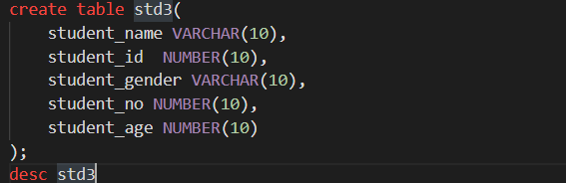

**2.INSERT :**

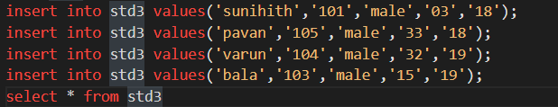

**3.SELECT**



**4.ARTHEMETIC OPERATIONS**



**5.ALIAS**



**6.** **CONCATINATION**



**7.DESCRIBE**

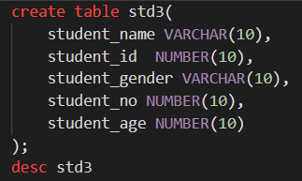

**8.WHERE**

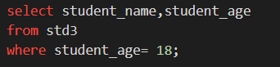

**9.BETWEEN AND**

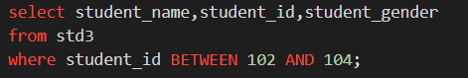

**10.IN OPERATOR**

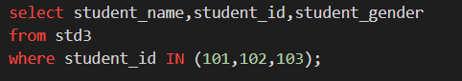

**11.NOT IN OPERATOR**

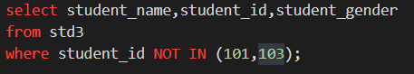

**12.LIKE OPERATOR**

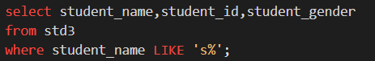

**13.NULL**

**A)IS NULL**

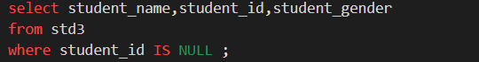

**B)IS NOT NULL**

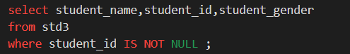

**14.LOGICAL OPERATORS**

**A)AND**

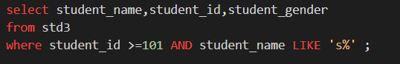

**B)OR**

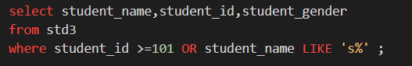

**15.ORDER BY(BY DEFAULT ASC)**

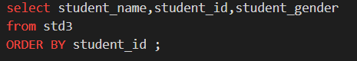

**A)ASC**

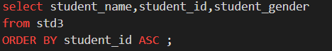

**B)DESC**

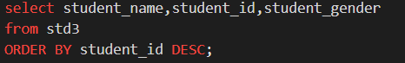

1. **Change data type in table**

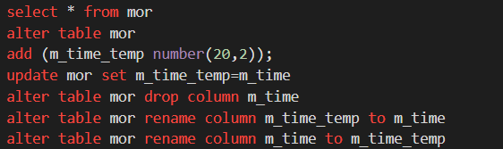

1. **update name**

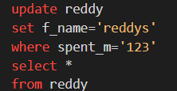

## delete coloumn

# 

## select top clause

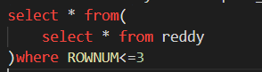

## fetch the number of rows

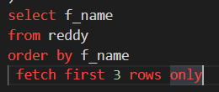

## Fecth first 50 rows only



## top 3 In order by

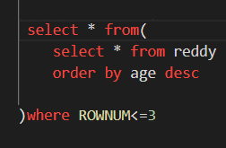

## 23.Aggregate Functions

## A)Count



## Sum



## Average



## Min



## Max



## Listagg

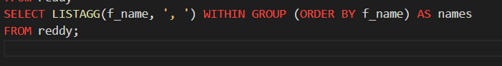

1. Using Aggregate Functions with GROUP BY

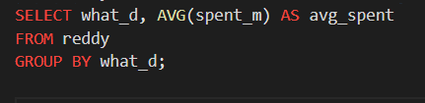

## af with where

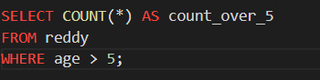

## af with count



## af with having

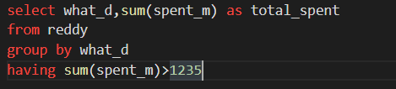

## adding new coloumn to old records default value

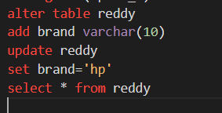

## adding new coloumn to old records different values

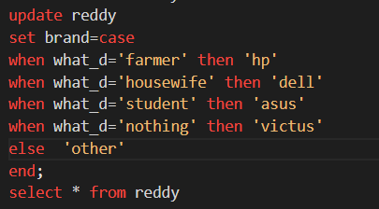

## count by where

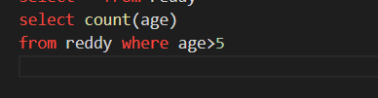

## count by distinct

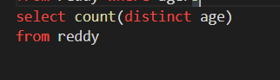

## count (*) distinct

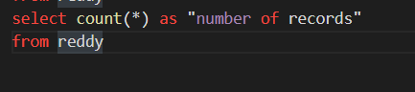

## Use COUNT() with GROUP BY

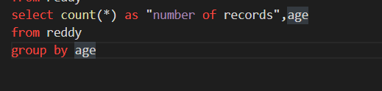

## like using where

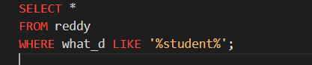

## wild card charecters

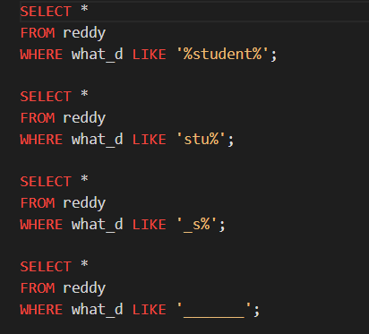

## between in

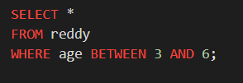

1. In

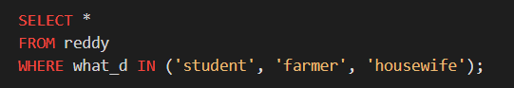

## between and , in

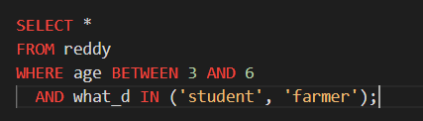

## Concatenate

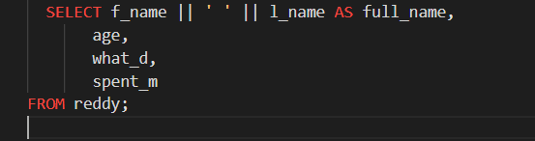

## 39.AS



## 40.use column as

## 

## 41.as with on

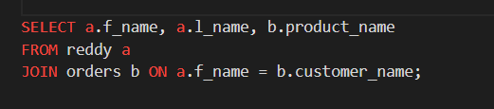

### 42.Types of Joins

1. **INNER JOIN**

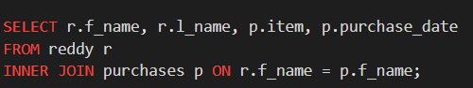

1. **LEFT JOIN (or LEFT OUTER JOIN)**

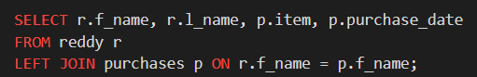

1. **RIGHT JOIN (or RIGHT OUTER JOIN)**

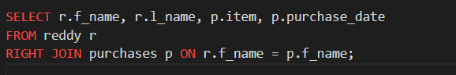

1. **FULL JOIN (or FULL OUTER JOIN)**

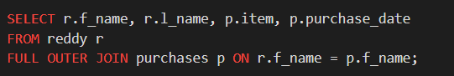

1. **CROSS JOIN**

